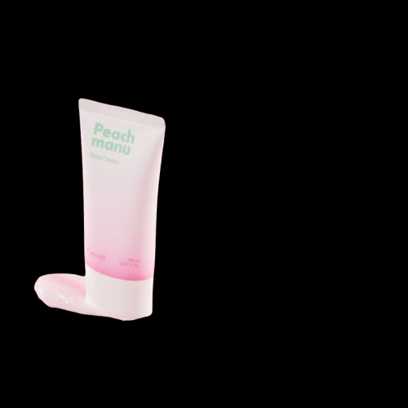
Name : Peach manu Glow cream
Description : Peach Manu Glow Cream by Parnell is a K-beauty moisturizing cream designed to provide a natural, radiant glow, improve hydration, soothe sensitive skin, and smooth texture, often featuring peach and cica extracts for skin health, working as a daily hydrator or night treatment for luminous, clear skin.
How to use :
Cleanse your face first.
Apply your toner/serum (optional).
Take a small amount of Peachmanu Glow Cream on your fingers.
Gently massage it all over your face and neck.
Use it morning and night for best results.

